**Program 4  
Rithik Bansal**

**Web site + storage**

**Purpose**

This programming assignment will introduce the student to using multiple services in the cloud working together. In particular the student will use S3 or Blob Storage, DynamoDB or Azure Tables or CosmosDB, and website technology which allows server side code (ASP.Net, MVC, etc...).

**Report highlights**

Location of the URL

<http://rbansal.us-west-2.elasticbeanstalk.com/>

Location of S3 storage

<https://s3-us-west-2.amazonaws.com/programfourestorage>

Design diagram of the final project

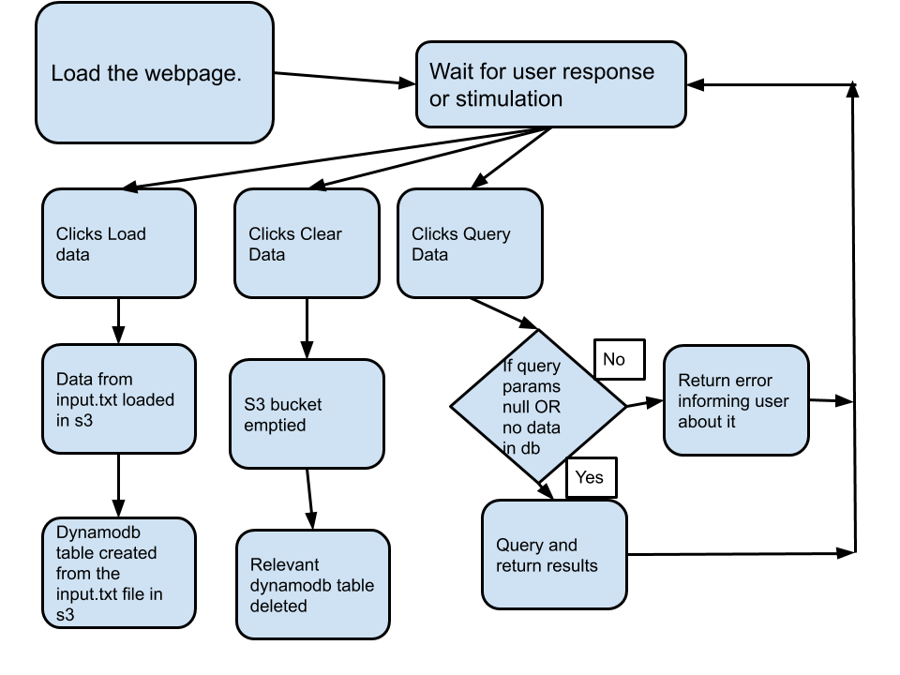

Figure 1 THe design diagram of the program4

The above diagram highlights the step wise flow of the program. It handles all cases and scenarios of inconsistent typing. The user will always be prompted with error message to rectify their mistake in the next call.

Discussion on site scaling with load

Beanstalk provides with auto scaling for the deployed application. You can also go to the modify capacity page to select the load balanced environment type with a minimum and maximum number of instances to be set up. This way if one instance is down, our service is still running for any incoming requests.

Discussion on monitoring is done on the site

Beanstalk provides with its own monitoring of the deployed application in terms of tracing the requests coming in and how many were successfully serviced. As an extension, we can make use of the New Relic and/ Splunk service which are both Big Data processors and provide a more detailed and user friendly reports of the application health.  
I am also using the Flask.logger to log all steps. This updates the log file and I am able to pinpoint the error message

Estimate of SLA

SLA estimate is based on values from the AWS website:

S3 SLA: 0.99

Dynamodb SLA: 0.999

Response time from EB logs and monitoring 0.95

ElasticBeanstalk overall website SLA: 0.99*0.999*0.95= 0.9015

My service guarantees atleast 90.1% as its SLA

Other general points:

The web service takes some time to create and load data. It is much faster when you are just loading the data and not creating any S3 instances and/or dynamodb tables.

The clear data button also takes some time but it executes perfectly.

The query button works perfectly too. It is usually a quick response from the query button on what was found and what was not.